**Swapnil Kamate**

Week 5 Problems

Chapter 6

1. Using the descriptors of the attributes given in the figure, convert the ERD shown in figureP6.1 into a dependency diagram that is in at least 3NF.

Answer:

P as in Patient

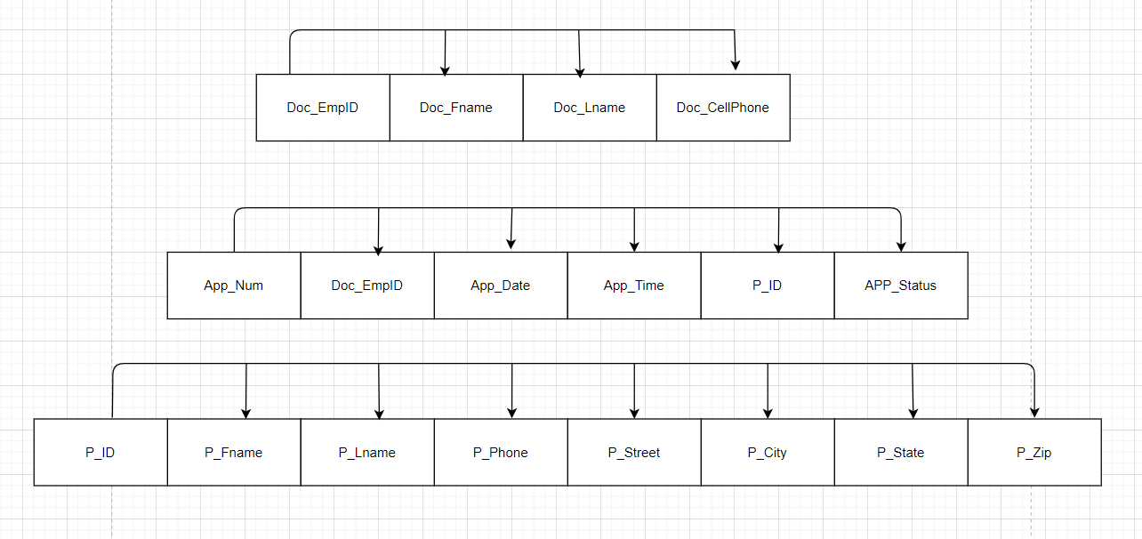

1. Using the descriptors of the attributes given in the figure, convert the ERD shown in figure P6.2 into a dependency diagram that is in at least 3NF.

Answer:

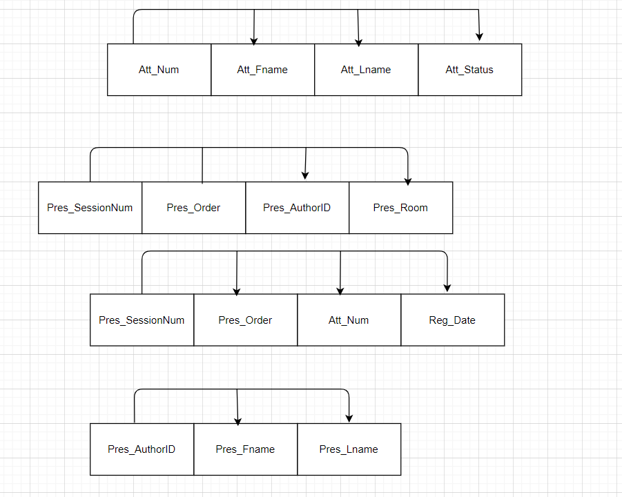

**NOTE: Hey Lucas, As discussed in the call, I have used Microsoft SQL Server to write my SQL queries.**

Chapter 7

1. Write the SQL code required to list the employee number, last name, first name, and middle initial of all employees whose last names start with Smith. In other words, the rows for both Smith and Smithfield should be included in the listing. Sort the results by employee number. Assume case sensitivity.

Answer:

select EMP_NUM, EMP_LNAME, EMP_FNAME, EMP_INITIAL

FROM EMPLOYEE

where EMP_LNAME like 'Smith%'

order by EMP_NUM;

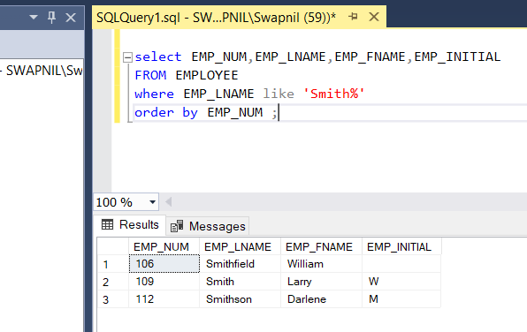

1. Using the EMPLOYEE, JOB, and PROJECT tables in the CH07_Construct_Co database, write the SQL code that will join the EMPLOYEE and PROJECT tables using EMP_NUM as the common attribute. Display the attributes shown in the results presented in Figure P7.2, sorted by project value.

Answer:

The data in table is different than what it shows in the screenshot so I have attached two screenshots for verification

select * from EMPLOYEE

select * from PROJECT

SELECT * FROM JOB

select

P.PROJ_NAME,P.PROJ_VALUE,P.PROJ_BALANCE,E.EMP_LNAME,

E.EMP_FNAME,E.EMP_INITIAL,J.JOB_CODE,

J.JOB_DESCRIPTION,J.JOB_CHG_HOUR

FROM EMPLOYEE AS E

JOIN PROJECT AS P

ON E.EMP_NUM = P.EMP_NUM

JOIN JOB AS J

ON E.JOB_CODE = J.JOB_CODE

ORDER BY P.PROJ_VALUE;

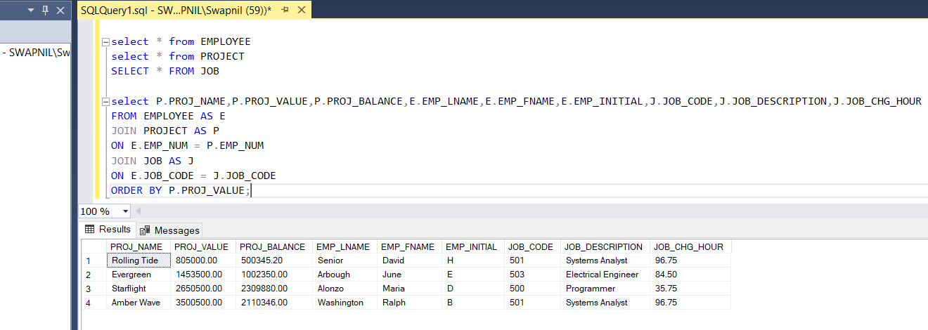

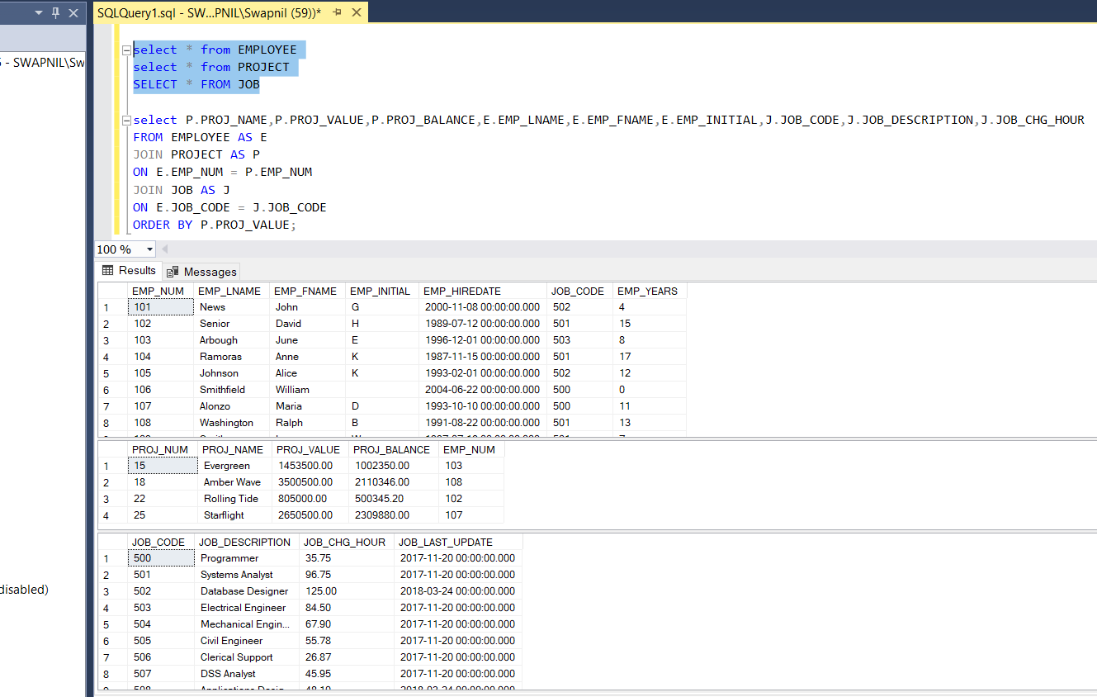

1. Write the SQL code that will produce the same information that was shown in Problem 2, but sorted by the employee’s last name.

Answer:

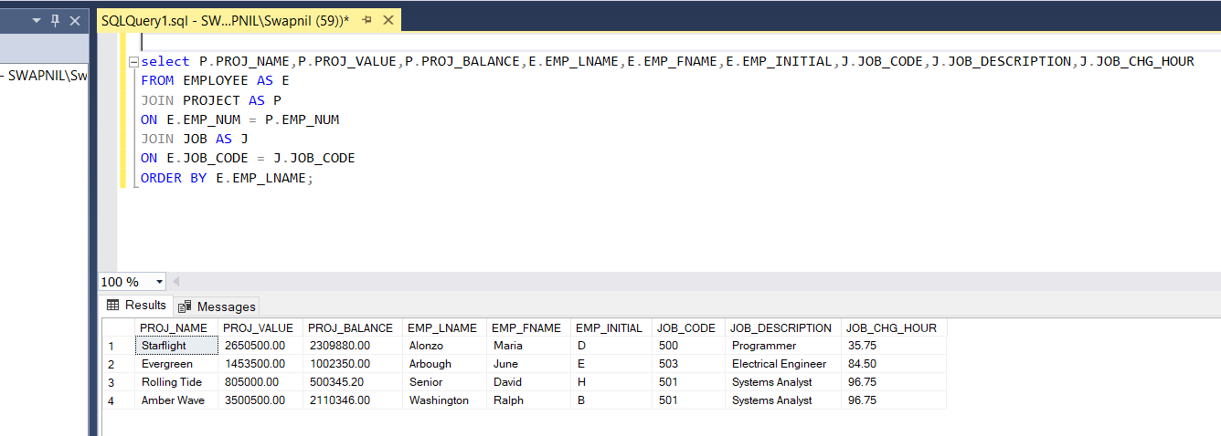

1. Write the SQL code that will list only the distinct project numbers in the ASSIGNMENT table, sorted by project number.

Answer:

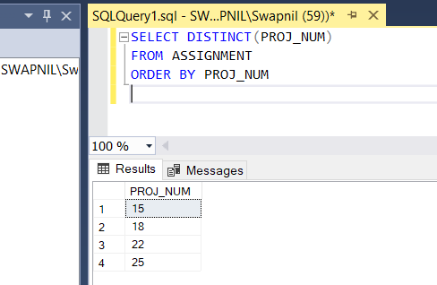

1. Write the SQL code to validate he ASSIGN_CHARGE values in the ASSIGNMENT table. Your query should retrieve the assignment number, employee number, project number, the sorted assignment charge(ASSIGN_CHARGE), AND THE CALCULATED ASSIGNMENT CHARGE (calculated by multiplying ASSIGN_CHG_HR by ASSIGN_HOURS). Sort the results by the assignment number.

Answer:

SELECT ASSIGN_NUM,EMP_NUM,PROJ_NUM,

ASSIGN_CHARGE,(ASSIGN_CHG_HR *ASSIGN_HOURS) AS RESULT

FROM ASSIGNMENT

ORDER BY ASSIGN_NUM;

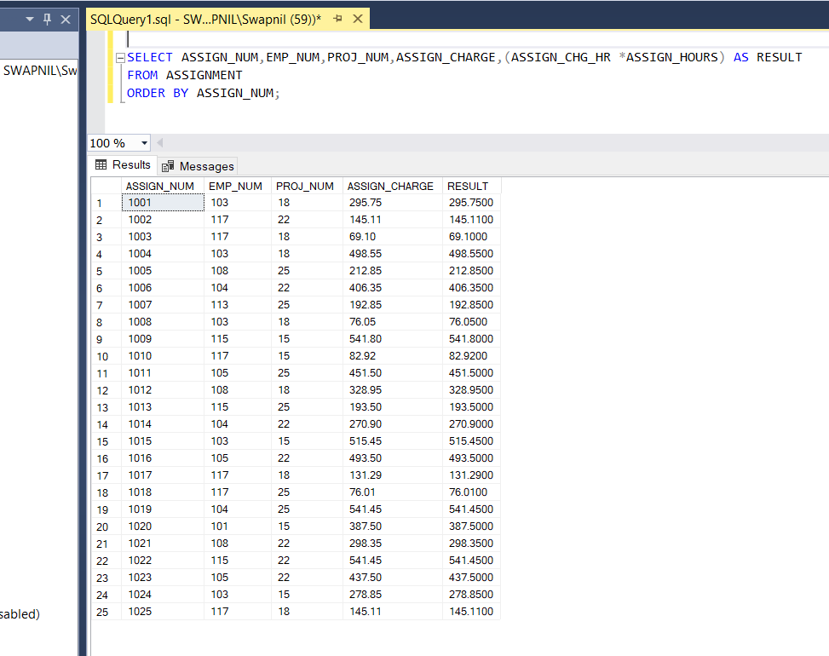

1. Using the data in the assignment table, write the SQL code that will yield the total number of hours worked for each employee and the total charges stemming from those hours worked, sorted by each employee number. The results of running that query are shown in Figure P7.6.

Answer:

SELECT E.EMP_NUM,E.EMP_LNAME,SUM(A.ASSIGN_HOURS) AS SumofASSIGN_HOURS,

SUM(A.ASSIGN_CHARGE) AS SumofASSIGN_CHARGE

FROM EMPLOYEE AS E

JOIN ASSIGNMENT AS A

ON E.EMP_NUM = A.EMP_NUM

GROUP BY E.EMP_NUM,E.EMP_LNAME

ORDER BY E.EMP_NUM;

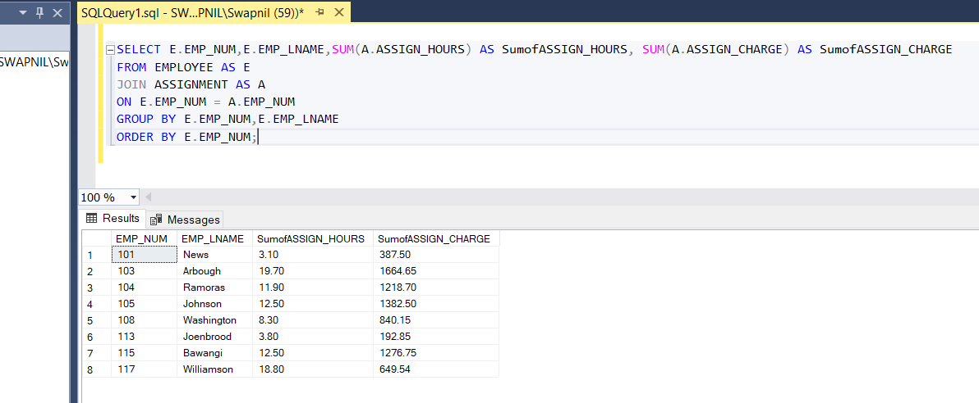

1. Write a query to produce the total number of hours and charges for each of the projects represented in the ASSIGNMENT table, sorted by project number. The output is shown in figure P7.7.

Answer:

SELECT PROJ_NUM, SUM(ASSIGN_HOURS) AS SumOfASSIGN_HOURS,

SUM(ASSIGN_CHARGE) AS SumOfASSIGN_CHARGE

FROM ASSIGNMENT

GROUP BY PROJ_NUM

ORDER BY PROJ_NUM;

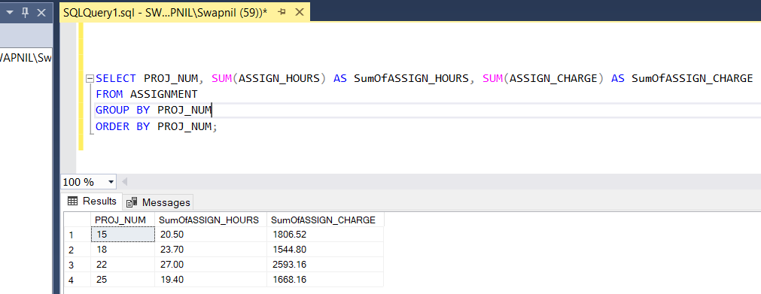

1. Write the SQL code to generate the total hours worked and the total charges made by all employees. The results are shown in figure P7.8.

Answer:

SELECT SUM(ASSIGN_HOURS) AS SumOfTotalhours,

SUM(ASSIGN_CHARGE) AS SumOfTotalCharge

FROM ASSIGNMENT

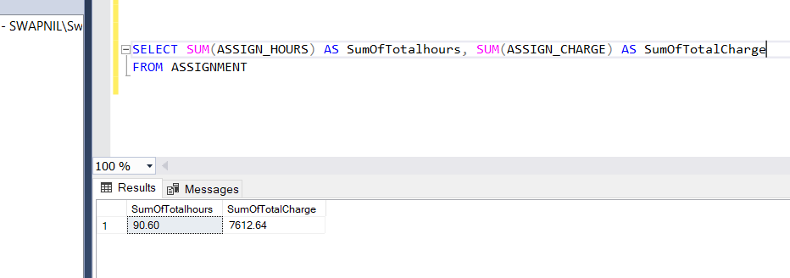

The result can be achieved via previous code as well taking sum of sum values.

The structure and contents of the CH07_SaleCo database are shown in Figure P7.9. Use the database to answer the following problems.

1. Write a query to count the number of invoices.

Answer:

SELECT COUNT(INV_NUMBER) AS [TOTAL COUNT] FROM INVOICE ;

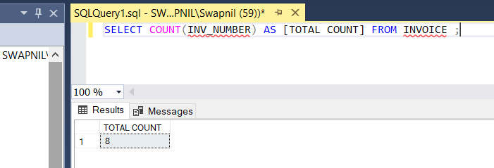

1. Write a query to count the number of customers with a balance of more than $500.

Answer:

SELECT COUNT(CUS_BALANCE)

AS [TOTAL NUMBER OF PEOPLE ]FROM CUSTOMER

WHERE CUS_BALANCE >500;

